**System Sequence Diagrams**

**Version 1.0**

**Project Management App**

**Team A**

**CSC-354**

**Fall 2015**

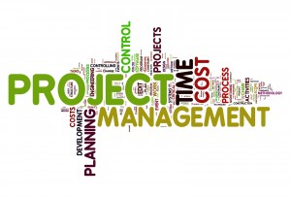

10/29/2015

Author: Tyler Mariano and Jennifer Li

Submitted To: Dr. Joo Tan

**TABLE OF CONTENTS**

Revision History…………………………………………………………………………………..ii

1.0 Introduction……..….....…………………………….…...…………………………….……....1

1.1 What Is A System Sequence Diagram…………....……………………………….......1

1.2 Notation……………………………………………………………………………….1

1.3 Diagrams………………………………………………………………..……….….1-6

**REREVISION HISTORY**

|  |  |  |  |
| --- | --- | --- | --- |
| Version | Author | Description | Date |
| 1.0 | Tyler Mariano | I created the first draft. | 10/22/2015 |

**1.0 INTRODUCTION**

stuff

**1.1 What Is A System Sequence Diagram?**

stuff

**1.2 Notation**

stuff

**1.3 Diagrams**

Stuff

Leader

:System

Messages Here

UseCaseHere()

Messages Here

Unsuccessful()

Messages Here

Successful()